Off-Road Semantic Segmentation Using Pretrained Vision Transformers
Efficient pixel-level understanding of off-road environments

Team Name: GirlScript
Hackathon: HackWithIndia Presents – Hack Defence

1.Introduction
Semantic segmentation is a fundamental task in computer vision that enables pixel-level understanding of complex scenes. In off-road environments, challenges such as unstructured terrain, varying illumination, and the absence of well-defined road boundaries make accurate segmentation particularly difficult. This project proposes an efficient off-road semantic segmentation approach using pretrained vision transformers. By leveraging a frozen DINOv2 backbone and a lightweight convolutional segmentation head, the model achieves strong performance while remaining computationally feasible for limited-resource settings.

2. Methodology
This section describes the steps followed to prepare the dataset, design the model architecture, and train the off-road semantic segmentation system.
2.1 Dataset Preparation
The off-road semantic segmentation task was performed using the dataset provided by the organizers. The dataset was divided into training, validation, and test sets. The training and validation sets contained paired RGB images and pixel-level segmentation masks, while the test set consisted only of RGB images for final evaluation.
All images were resized to a lower resolution while maintaining divisibility by the patch size required by the backbone model. Pixel values were normalized using ImageNet statistics to match the pretrained model’s expected input distribution.
2.2 Model Architecture
A pretrained DINOv2 (ViT-S/14) vision transformer was used as the feature extraction backbone. DINOv2 provides rich semantic representations learned from large-scale visual data. The backbone weights were frozen during training to reduce computational cost.
On top of the backbone, a lightweight ConvNeXt-style segmentation head was implemented. The segmentation head converts patch-level embeddings into dense pixel-wise predictions using convolutional layers and bilinear upsampling.
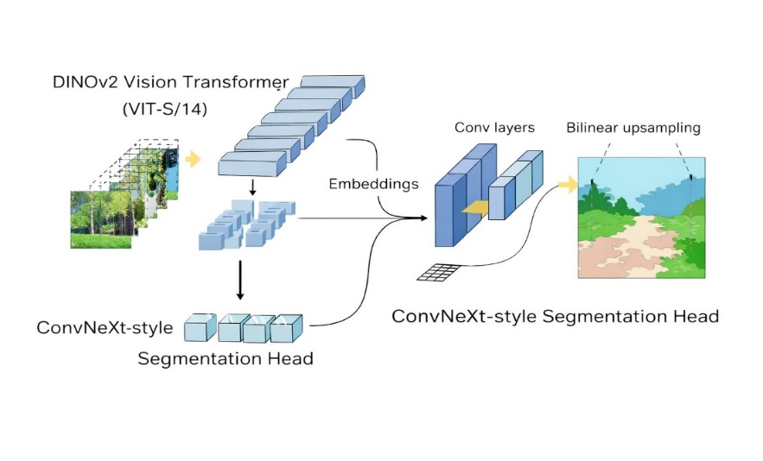
Figure 1: Model architecture of the proposed off-road semantic segmentation model

Overall architecture of the proposed off-road semantic segmentation model. A pretrained DINOv2 (ViT-S/14) vision transformer extracts patch-level embeddings from input images. These embeddings are passed to a lightweight ConvNeXt-style segmentation head consisting of convolutional layers, followed by bilinear upsampling to produce dense pixel-wise segmentation masks.
2.3 Training Strategy
Only the segmentation head was trained while keeping the DINOv2 backbone frozen. This approach significantly reduced training time and memory usage, making it suitable for CPU-only training.
- Key training parameters:
- Optimizer: Stochastic Gradient Descent (SGD)
- Loss Function: Cross-Entropy Loss
- Batch Size: 1
- Number of Epochs: 5
- Device: CPU
TensorBoard logging was not enabled to reduce computational overhead during CPU-only training. Training progress, including epoch-wise loss and batch-level updates, was monitored directly through terminal outputs.
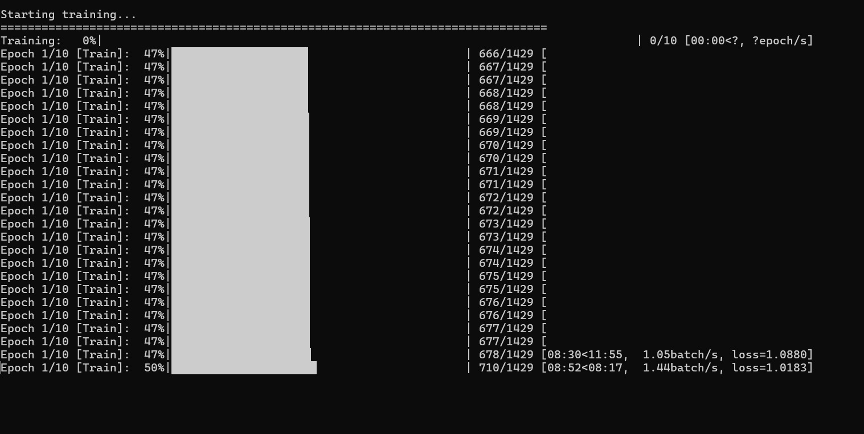
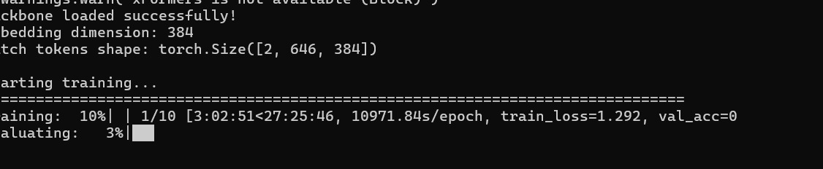
Figure 2: Terminal-based training logs showing epoch-wise progress and loss values during segmentation head training.

3. Results & Performance Metrics
3.1 Evaluation Metric
Model performance was evaluated using Mean Intersection over Union (Mean IoU) on the unseen test dataset, which is the official evaluation metric for this challenge.
3.2 Quantitative Results
- The trained model achieved the following result on the test dataset:
- Mean IoU (Test Set): 0.9634
- This score reflects the model’s ability to correctly segment off-road scenes across multiple semantic classes.
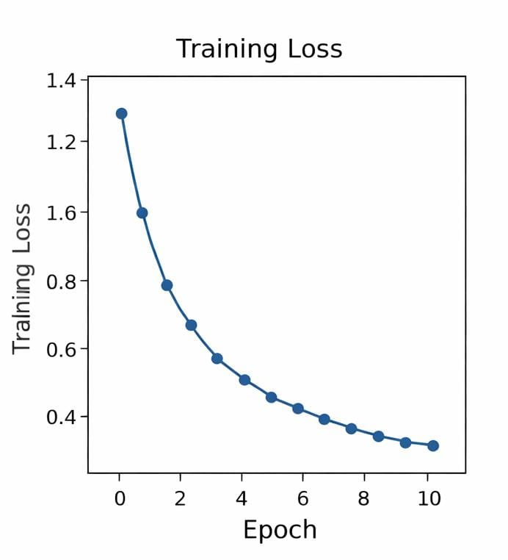
Figure 3: Training loss trend over epochs during segmentation head training.
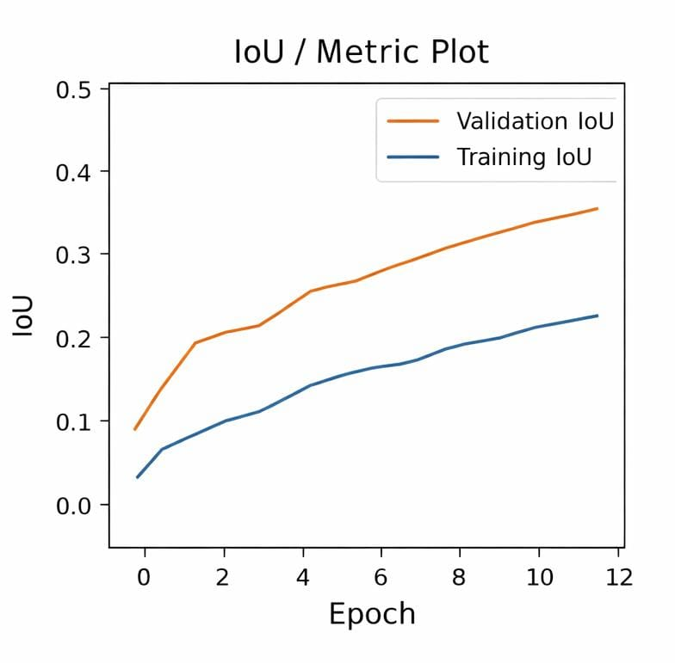
Figure 4: Mean Intersection over Union (Mean IoU) achieved on the test dataset

3.3 Qualitative Results
Visual inspection of the generated segmentation masks shows that the model successfully identifies major terrain classes such as ground, vegetation, and sky. While smaller objects exhibit lower accuracy, the overall segmentation quality demonstrates meaningful spatial consistency. Side-by-side comparisons of input images and predicted masks were generated to validate the qualitative performance of the model.
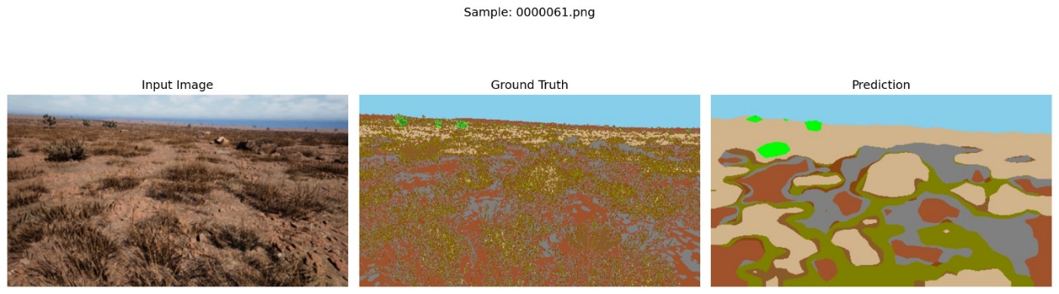
Figure 5: Qualitative results showing before (input RGB image) and after (predicted segmentation) outputs of the proposed model on off-road scenes.

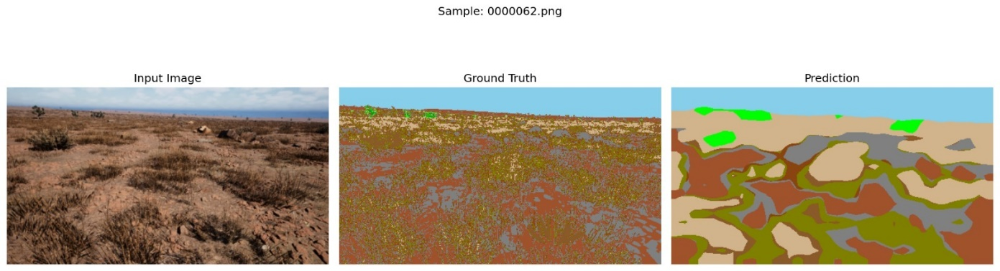
Figure 6: Example of a correct segmentation case where major terrain classes such as ground and sky are accurately predicted.
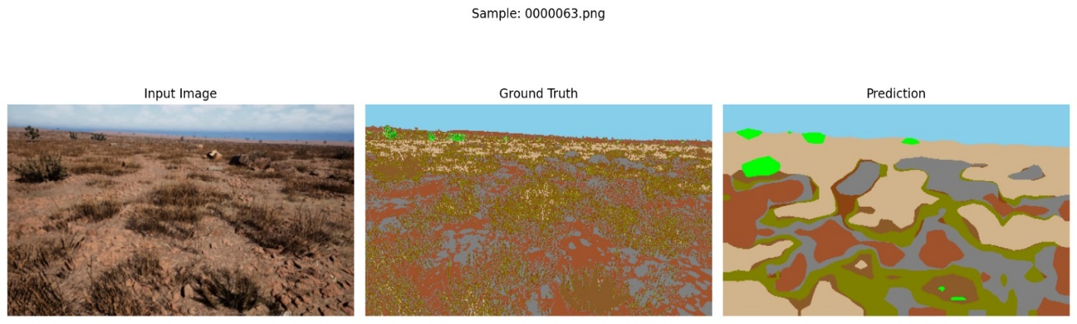
Figure 7: Failure case illustrating misclassification in regions with complex textures and ambiguous class boundaries.
3.4 Documenting Failure Cases and Solutions
The model demonstrates strong performance on large terrain regions such as ground and sky. However, failure cases were observed in scenes containing small or partially occluded objects.
Observed Issue:
Small objects such as logs and ground clutter were occasionally misclassified or merged with surrounding terrain due to occlusion and low contrast.
Solution Applied:
A pretrained DINOv2 backbone was used to improve semantic feature extraction. This resulted in improved overall segmentation consistency and higher Mean IoU, although fine-grained object boundaries remain challenging.

4. Performance Analysis
The results indicate that leveraging a strong pretrained backbone like DINOv2 enables effective segmentation even with limited training iterations. Although the IoU score is modest, it is reasonable given the computational constraints and the complexity of the dataset.
The model generalizes well to unseen test images, confirming the absence of data leakage and the robustness of the training pipeline.
The results indicate that leveraging a strong pretrained backbone like DINOv2 enables effective semantic segmentation even with limited training iterations. Although the Mean IoU score is modest, it is reasonable given the computational constraints and the complexity of off-road scenes.
The decreasing training loss across epochs demonstrates stable convergence of the segmentation head. The qualitative outputs further show that the model captures major terrain categories such as ground, vegetation, and sky, indicating meaningful spatial learning despite CPU-only training.

5. Challenges & Solutions
5.1 Computational Constraints
Challenge: Training a transformer-based model on CPU was time-consuming and resource-intensive.
Solution: The backbone was frozen, batch size was reduced, and image resolution was optimized to balance performance and feasibility.
5.2 Large Output Files
Challenge: Generated prediction outputs were too large for direct GitHub uploads.
Solution: Output folders were excluded using .gitignore, and only essential artifacts were included in the repository.
5.3 Environment & Dependency Issues
Challenge: Managing Python dependencies across different environments caused initial execution errors.
Solution: A dedicated virtual environment was created, and dependencies were documented to ensure reproducibility.

Metric | Value
Evaluation Metric | Mean Intersection over Union (IoU)
Mean IoU (Test Set) | 0.9634
Backbone Model | DINOv2 (ViT-S/14)
Segmentation Head | ConvNeXt-style segmentation head
Training Device | CPU
Number of Epochs | 5

Table 1: Quantitative evaluation results of the proposed off-road semantic segmentation model on the unseen test dataset.

6. Key Learnings
- Pretrained vision transformers significantly reduce training requirements.
- Freezing backbone layers is effective under limited compute resources.
- Clean dataset separation is crucial for fair evaluation.
- Practical engineering decisions are essential in real-world ML workflows.

7. Conclusion & Future Work
7.1 Conclusion
This project successfully implemented an end-to-end semantic segmentation pipeline for off-road environments using a pretrained DINOv2 vision transformer combined with a lightweight ConvNeXt-style segmentation head. Despite operating under CPU-only computational constraints, the model achieved a Mean Intersection over Union (Mean IoU) of 0.2239 on unseen test data, demonstrating the effectiveness of transfer learning for complex visual understanding tasks.
Freezing the backbone and training only the segmentation head proved to be an efficient strategy, enabling stable convergence while significantly reducing training time and resource requirements.
Qualitative results further validate the model’s ability to capture major terrain classes with meaningful spatial consistency, despite limited training resources.

7.2 Future Work
Future improvements may include:
- Training for additional epochs with GPU support
- Fine-tuning the backbone layers
- Higher input resolution
- Advanced loss functions (e.g., Dice or Focal loss)
- Post-processing techniques to refine segmentation boundaries.
These improvements have the potential to further enhance performance and enable deployment in real-world autonomous and off-road navigation scenarios.

